
TEACH LINK Open the live Chalkie lesson
Before the girls sit down
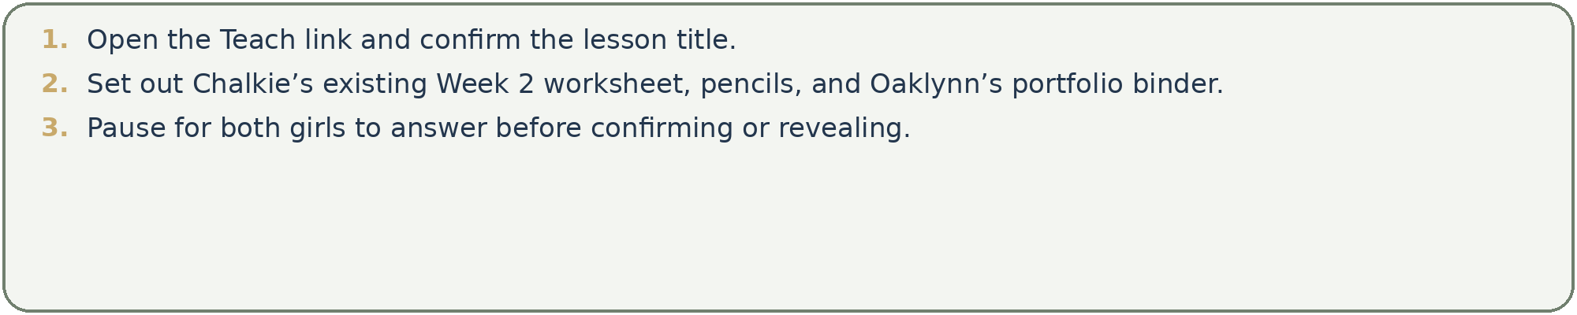
Learning target
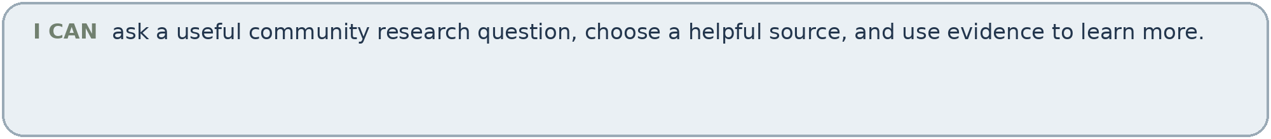
Differentiated success
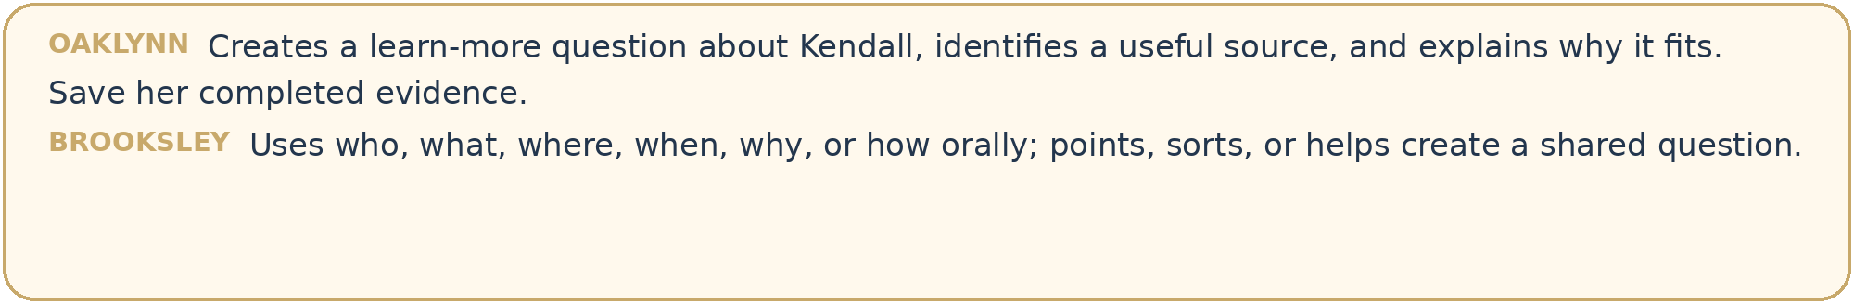
Suggested route
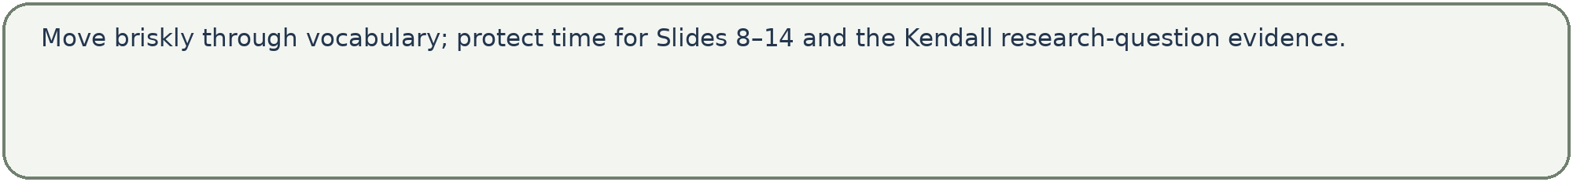


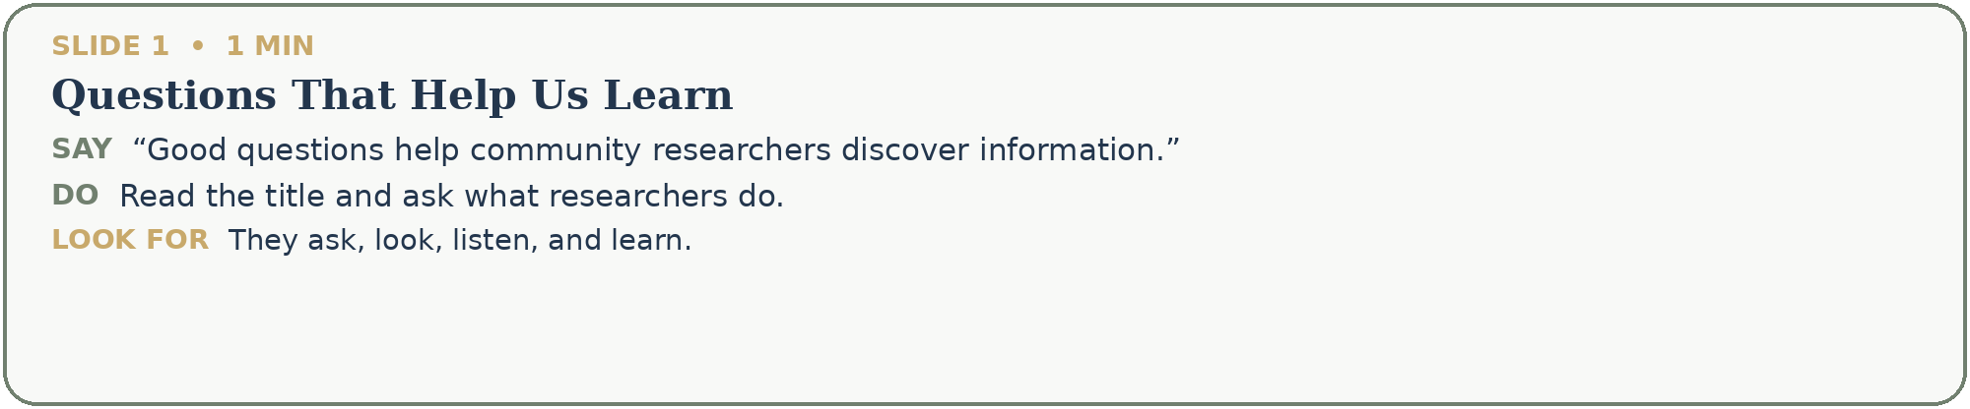
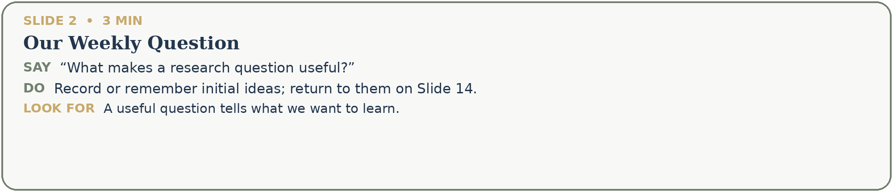
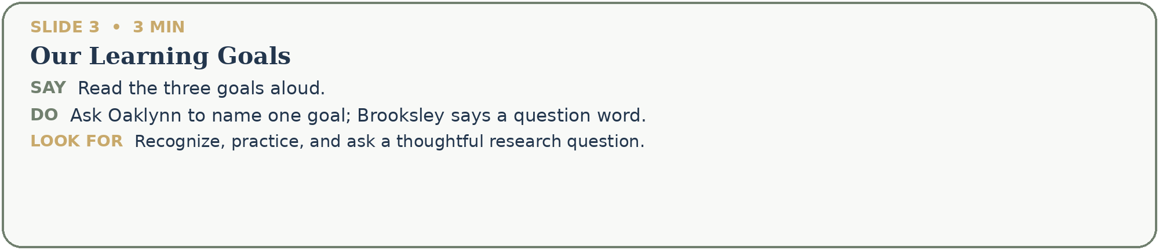
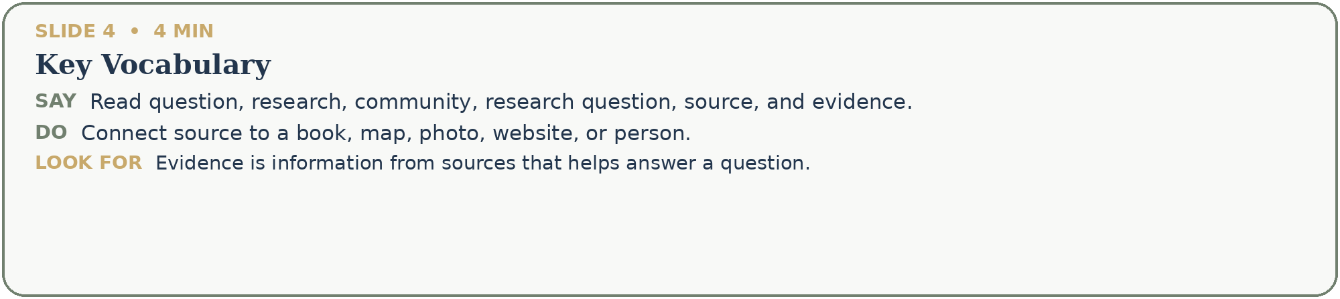


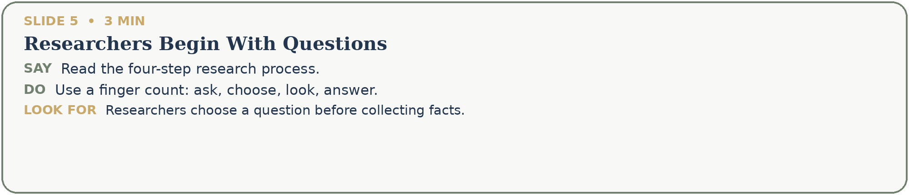
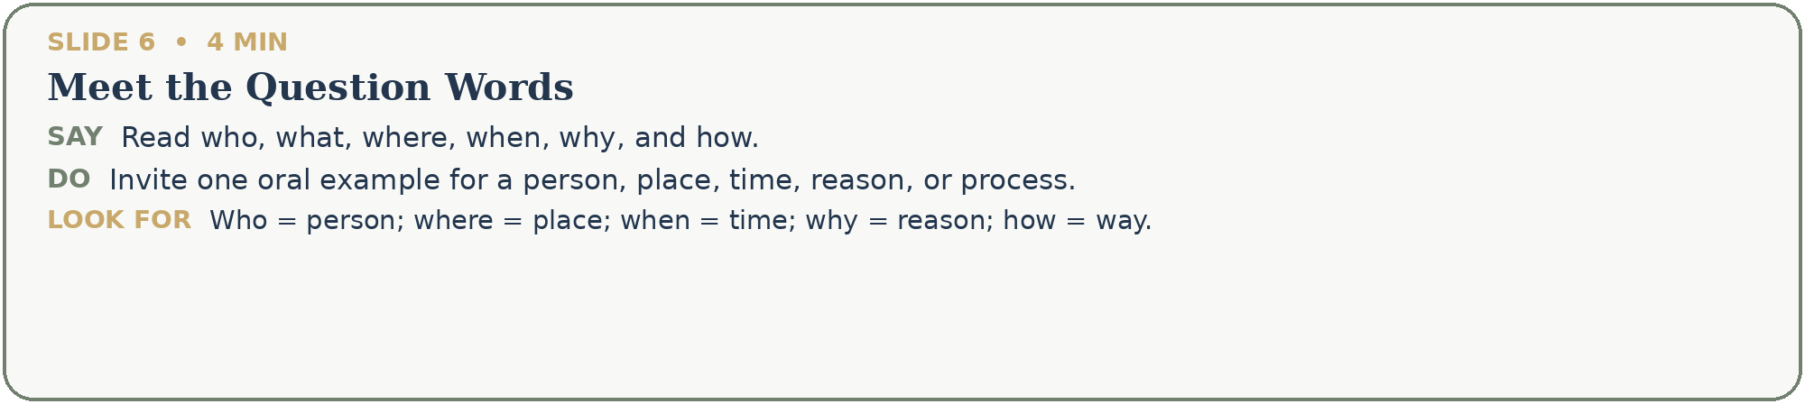
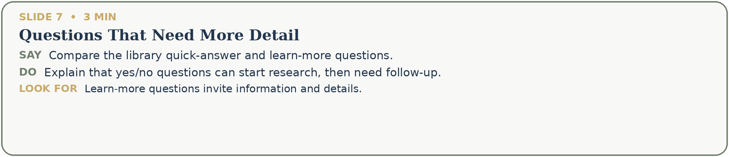
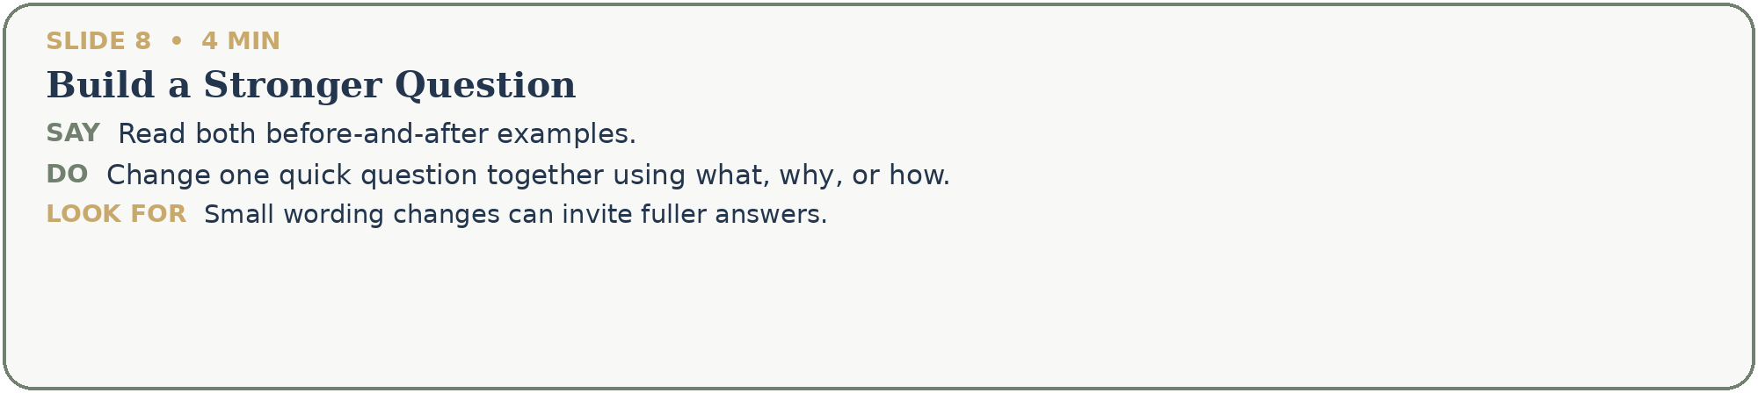


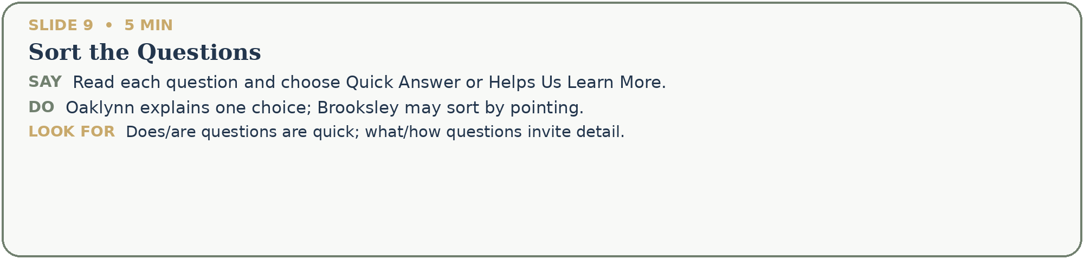
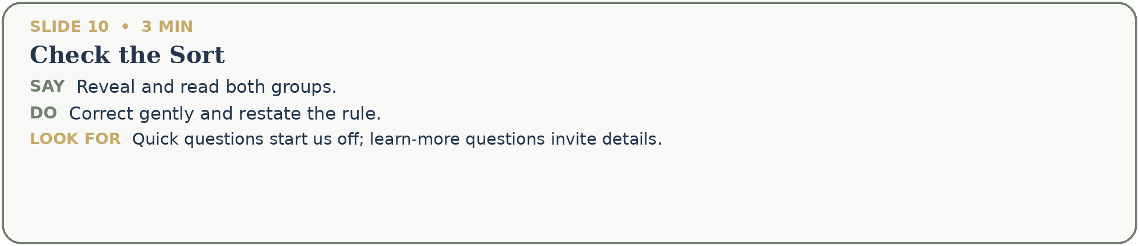
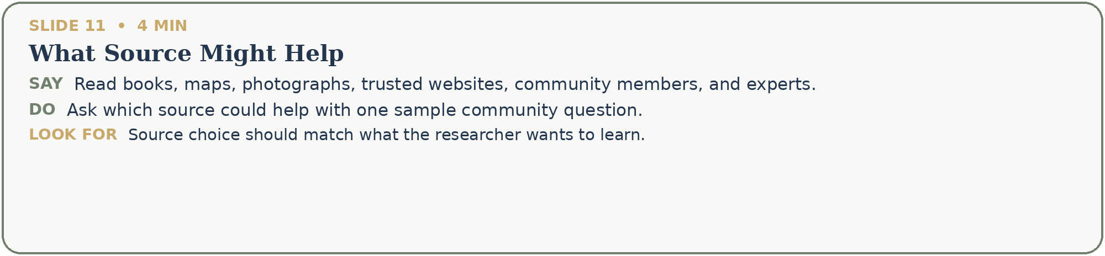


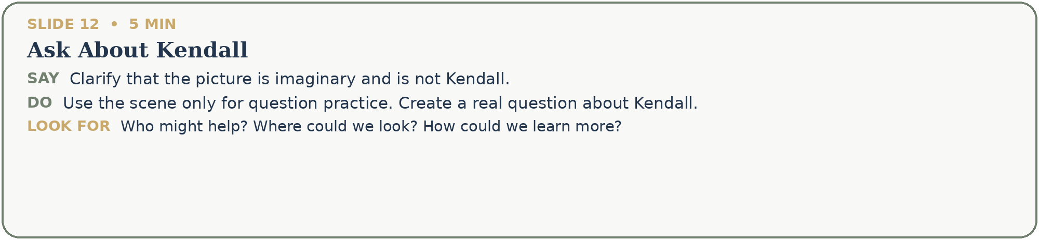
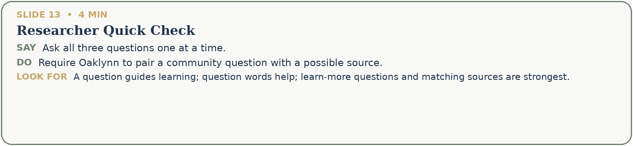
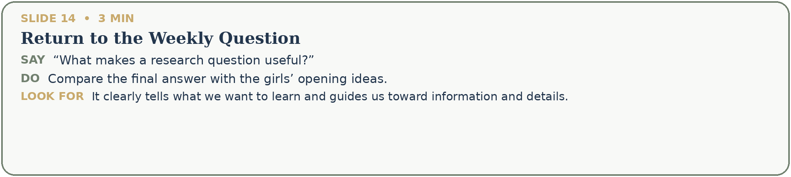
Complete and save
