
Before the girls sit down
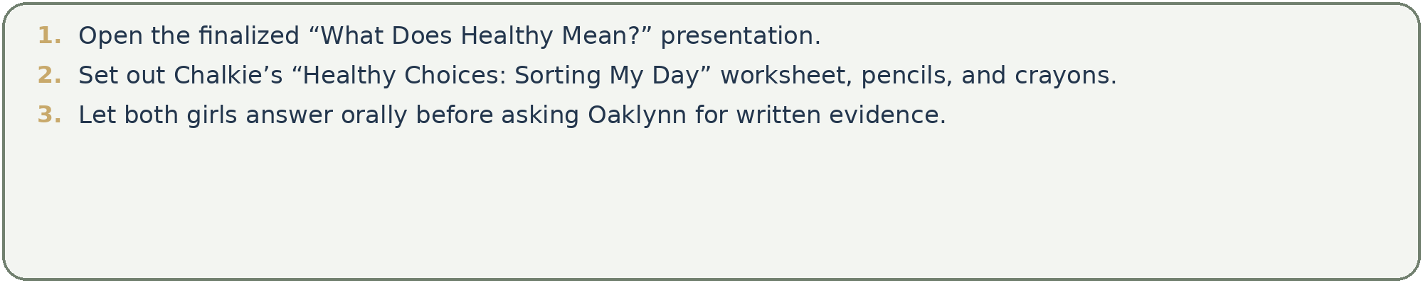
Learning target
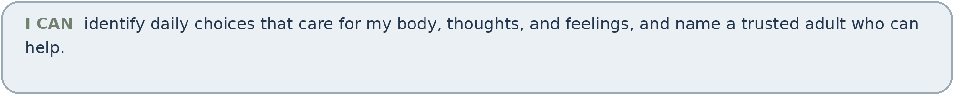
Two-session plan
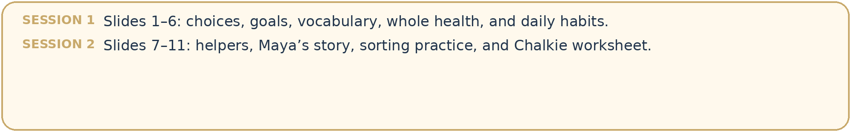
Differentiated success
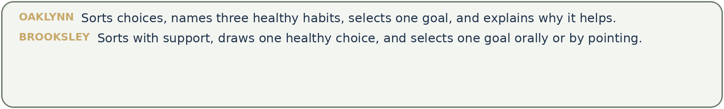


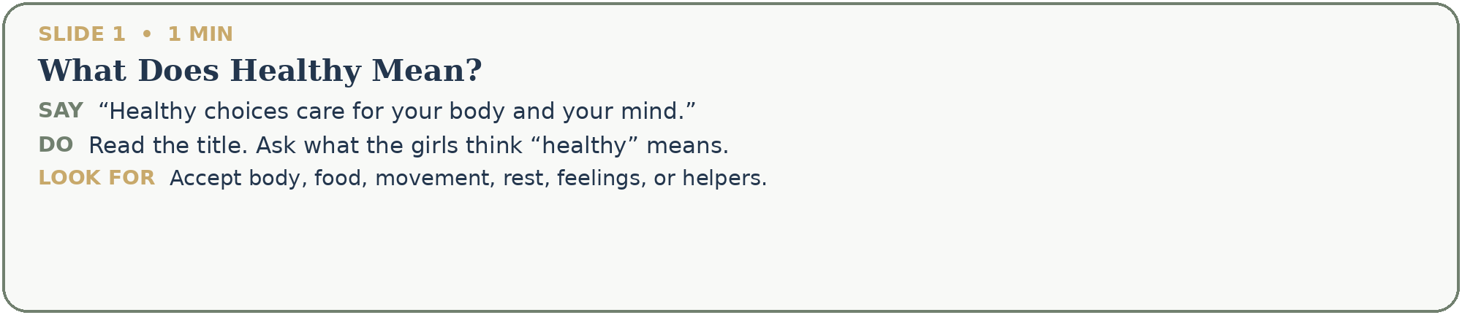
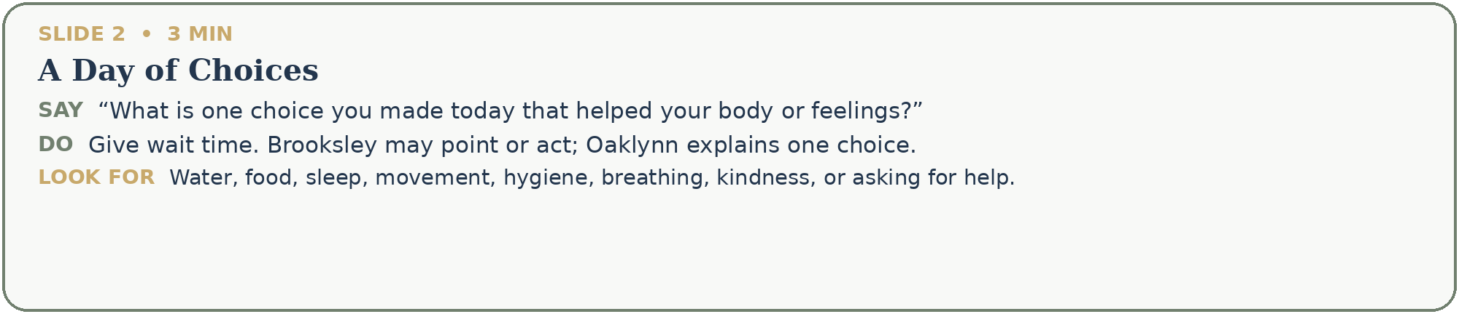
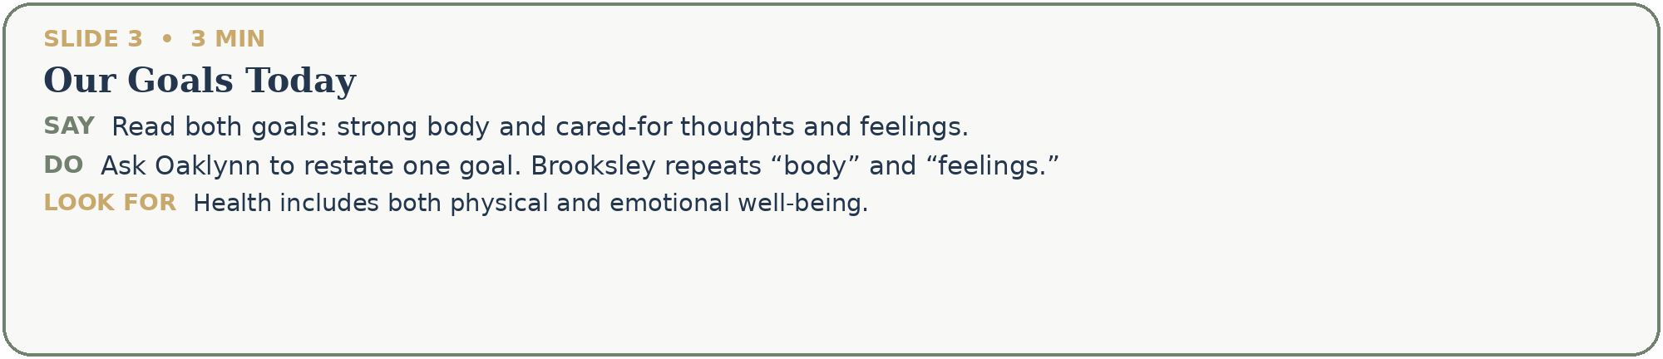
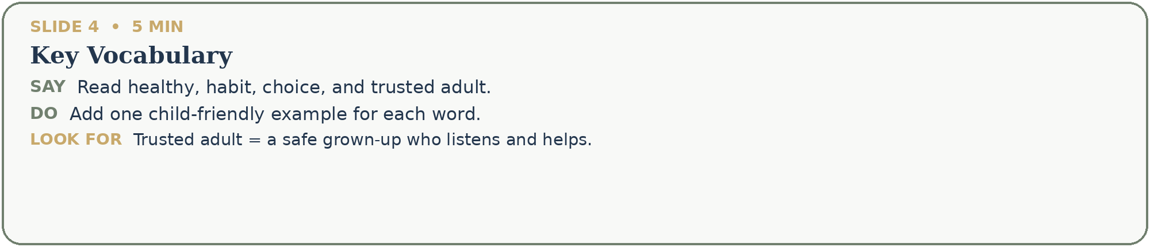

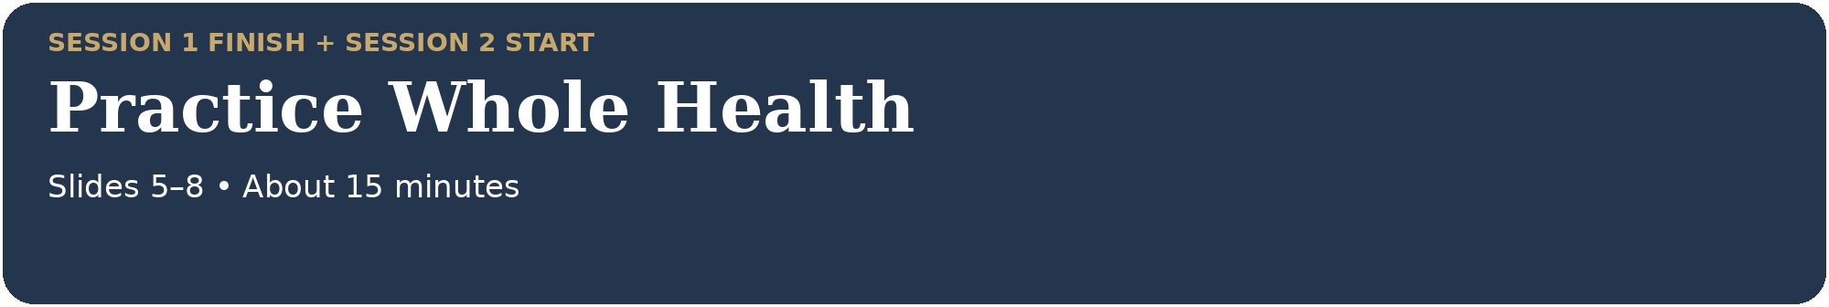
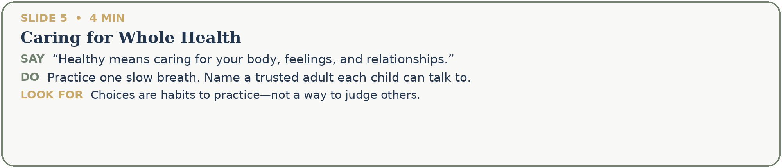
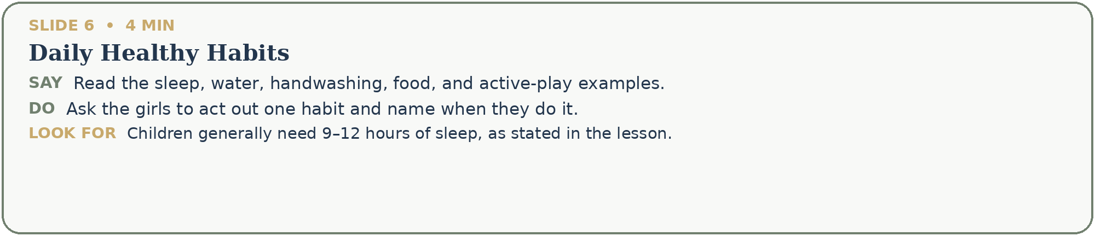
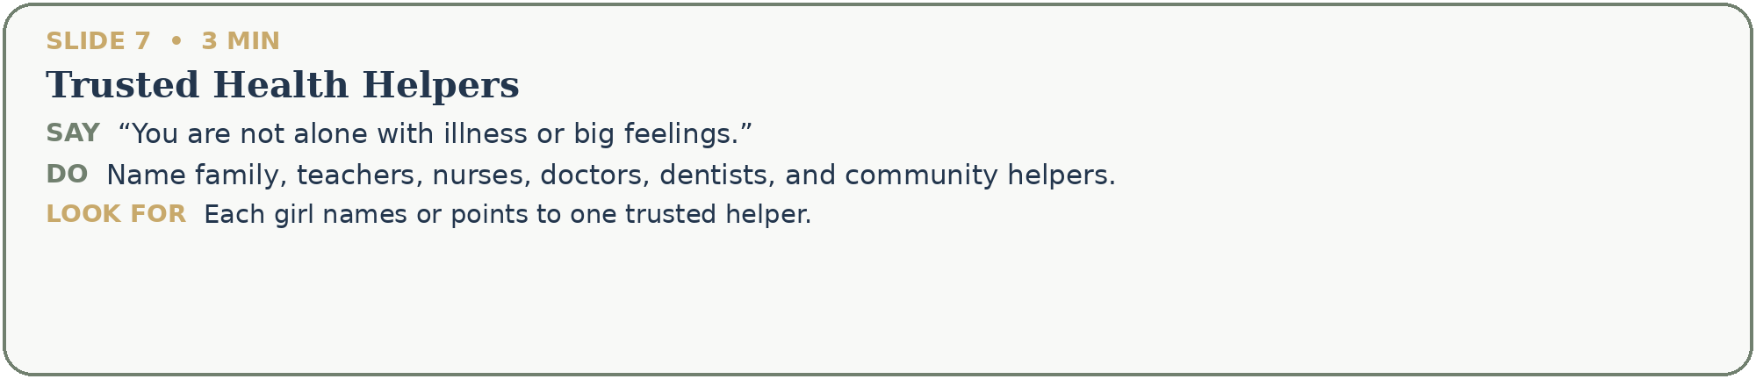
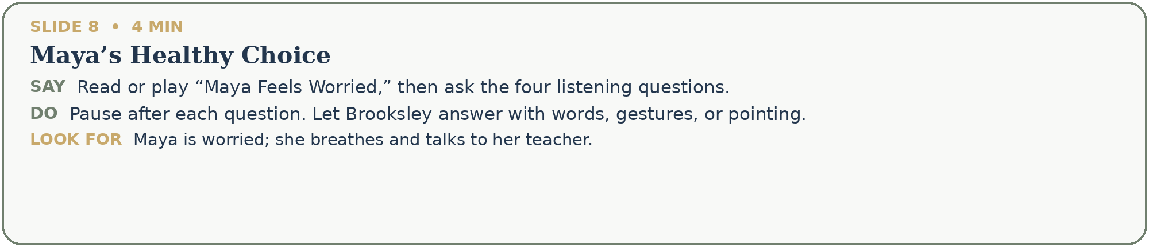


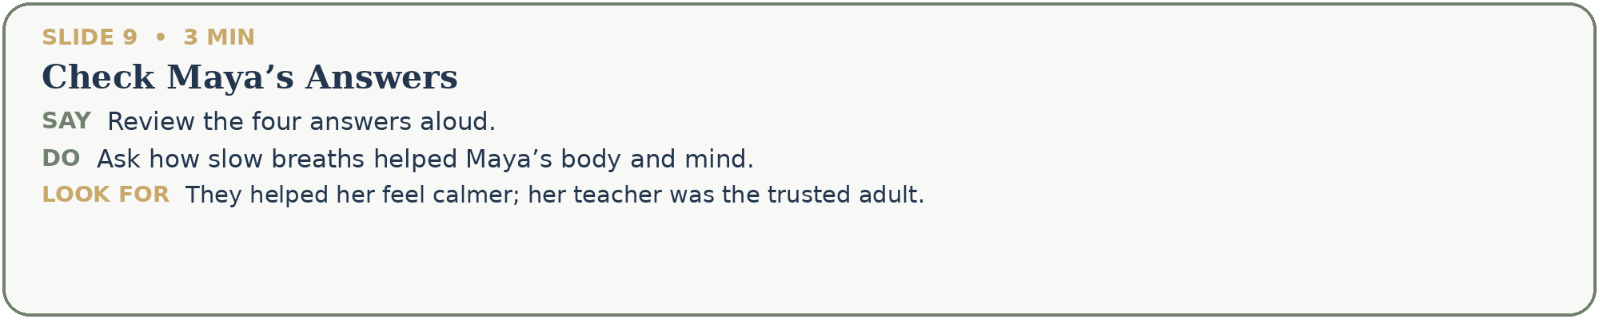
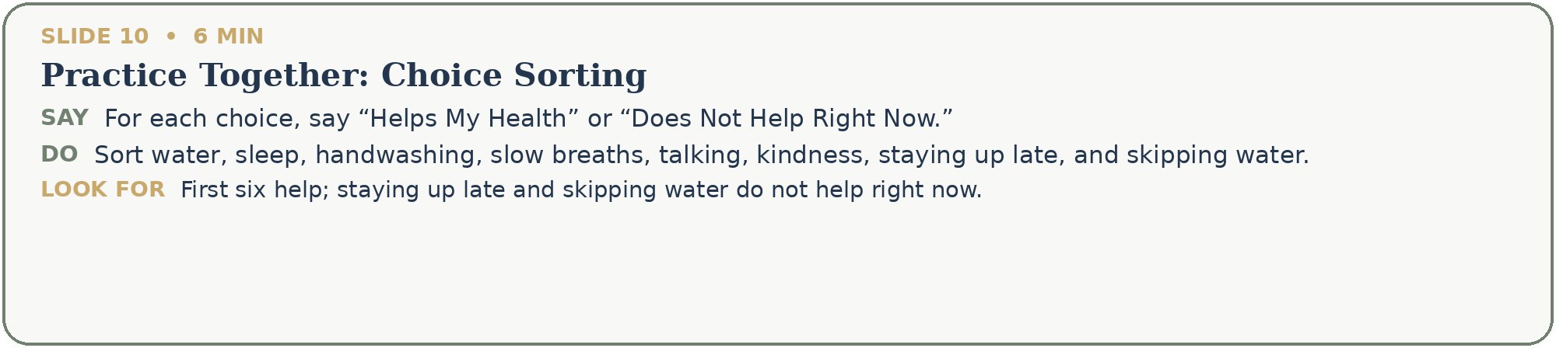
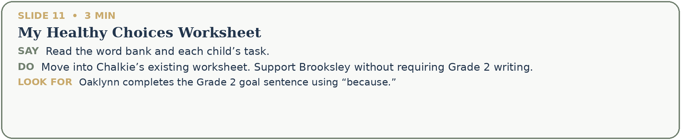
Complete and document
